Using Checkstyle plugin in Eclipse

Introduction

This document explains the use of Checkstyle plugin in Eclipse for validating the code w.r.t. Coding Guidelines. This plugin will help the development team as well as code reviewer to ensure that proper Coding Guidelines are followed. It is mandatory for all developers to ensure that the CkeckStyle plugin does not report any issues with the code, before the code is checked into SVN.

Installation and Configuration

- To install the plugin, please select option Help -> Install New Software. In the Install dialog that is shown, type the site for field Work with field as http://eclipse-cs.sf.net/update/

Select the Checkstyle plugin in the available list of modules available for install, and click on Next button.

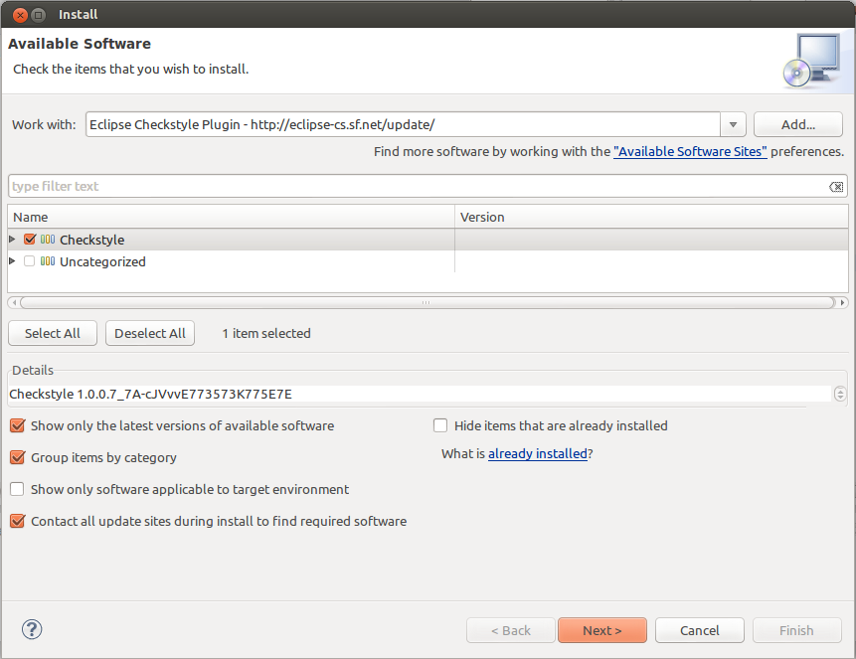

- In the dialog that is displayed, click on Next button.

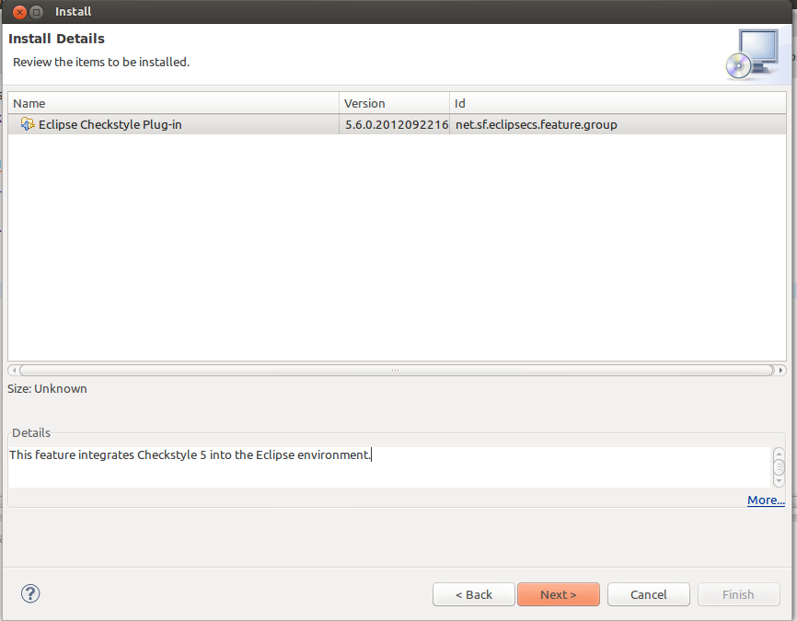

- In the dialog that is displayed, accept the license aggrement and click on Finish.
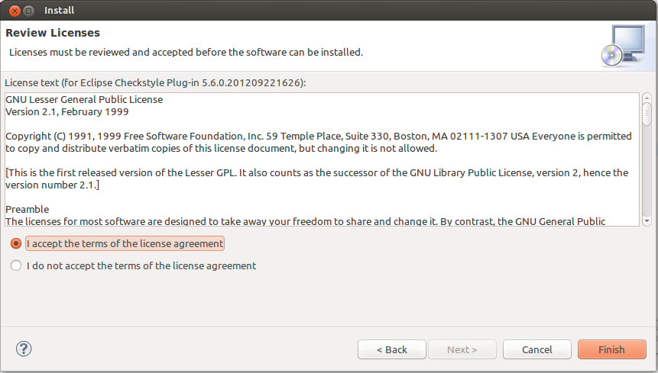

- Once the plugin is installed, restart the Eclipse IDE. Once you restart, go to the option Window -> Preferences. You should see the option “Checkstyle” in the left pane. Create a new Global Check Configuration named parinati using the file parinati.xml. Set the Global Check Configuration parinati as the default.

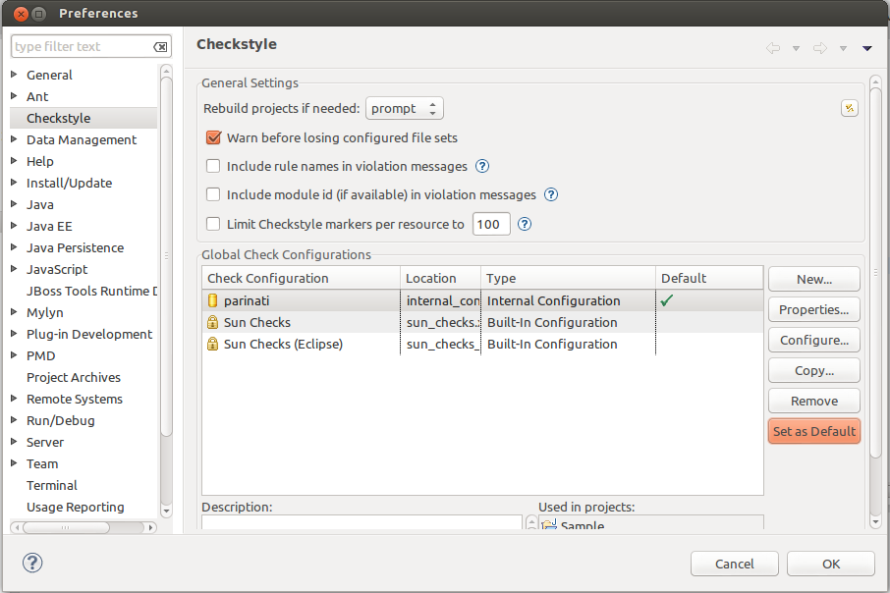

- To enable the Checkstyle plugin for a Project, right click on the Project name in the Project Explorer, and select the option Properties. In the Project Properties dialog, select the option Checkstyle in the left pane. Check the option Checkstyle active for this project. Select the Global check configuartion parinati, already created in step 4.
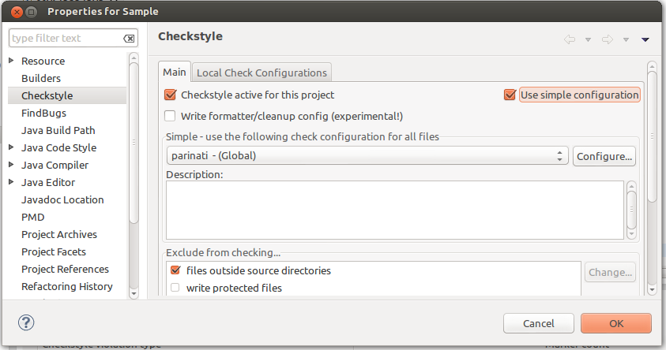
- To check the code using Checkstyle plugin, right click on the Project, and select option Checkstyle -> Check code with checkstyle. Enable the Checkstyle violations view to see the code that violates the Coding guidelines as configured in the Global check configuration parinati.

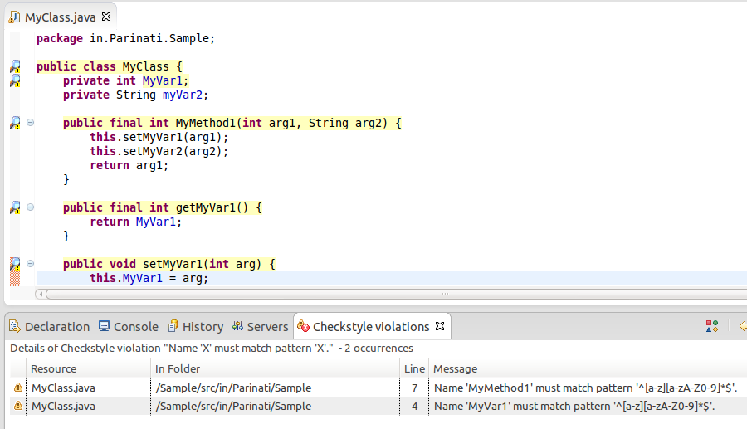

Note:
- It is important to note that we have created custom Global check configuration file parinati.xml, which is based on the Coding guidelines rules that we have. Please use the same as default Global check configuration.
- This plugin will only highlight issues related to Coding guidelines. Please follow the other Developer guidelines for writing better and efficient code. Using this plugin, in no way absolves the developer from using other Developer guidelines.
- It is mandatory to use this plugin to fix any issues related to Coding guidelines in youe Java code, before you check in any code into SVN.
- This will not validate JSP code; however, the JSP editor plugin in Eclipse should be good enough to point out issues in JSP code.

